Front End Engineering-II

Project Report Semester-IV (Batch-2022)

**Dicet TV: Your Favorite Shows and movies**



**Supervised By: Submitted By:**

Dr. Raveesh Samkaria Sanchit Prashar

2210990783

G-31

**Department of Computer Science and Engineering Chitkara University Institute of Engineering & Technology,**

**Chitkara University, Punjab**

# Abstract

This user-friendly Digital Agency website “Dicet TV: Your Favorite Shows and movies” empowers you to stay mesmerized in the fluidity of animations and stay impressed with the stunning UI and with the use of strong responsive development principles and the power of React JS, we have received heart-warming results.

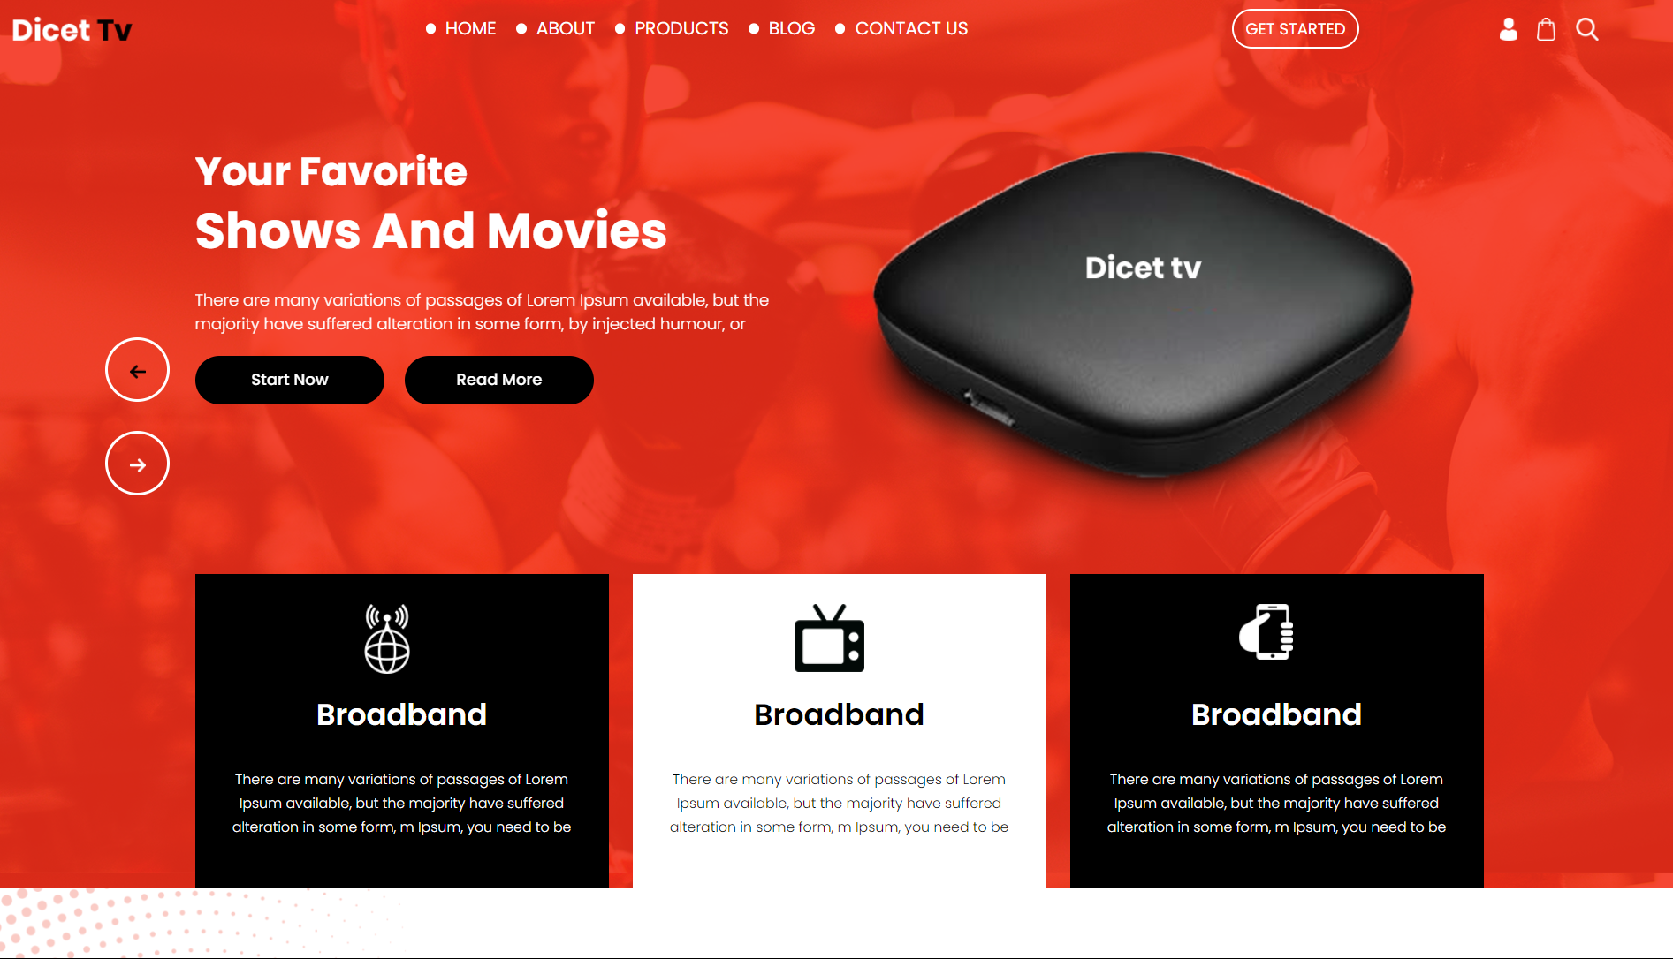

# INDEX

|  |  |  |
| --- | --- | --- |
| **S.No.** | **Title** | **Page Number(s)** |
| 1 | Introduction | 4 |
| 2 | Problem Statement | 5 |
| 3 | Software Requirements | 5 |
| 4 | Proposed Design | 6-21 |
| 5 | Results | 22-24 |
| 6 | References | 25 |

1. **Introduction**

The DICET TV web application offers a convenient yet efficient platform for learning about the Digital Agency and finding a way to contact. DICET TV is a website that provides broadband services, ensuring users have access to reliable and fast internet connections. This introduction provides an overview of the background, objectives, and significance of the “DICET TV” platform.

## Background:

As technology continues to transform our daily lives, staying connected is more important than ever. Dicet TV's broadband service ensures you stay at the cutting edge of digital advancements. We provide a comprehensive digital platform designed to support a wide range of entrepreneurial activities. Our platform features a stunning user interface and exceptional interactivity, meeting the high expectations of today's users. Stay ahead with Dicet TV, where technology meets seamless connectivity.

## Objectives:

The primary objective of Dicet TV's digital platform is to provide a user-friendly, fluid interface for individuals to interact with digital agencies. Our application simplifies the process, eliminating the need for users to browse through the internet or rely on external means. Additionally, our platform strives to improve every day, ensuring a seamless and efficient user experience.

## Significance:

# The significance of Dicet TV's digital platform lies in its ability to streamline complex tasks that entrepreneurs encounter regularly. Whether for personal use, professional purposes, or administrative requirements, digital agency-based tasks are essential. By offering a convenient and reliable solution, our platform enhances efficiency and productivity, saving users time and effort.

# Problem Statement

In the contemporary digital landscape, users demand websites that offer accessibility, convenience, and engaging, fluid user experiences. Despite the proliferation of digital agencies, many still struggle to balance aesthetic appeal with robust functionality and responsiveness. The challenge lies in developing a website that captivates users with seamless animations and a stunning user interface (UI) while ensuring strong responsive development and optimal performance. Dicet TV's digital platform addresses this gap by leveraging React JS to create a visually impressive and highly functional platform. Our platform enables users to learn about and contact digital agencies effortlessly. We effectively integrate advanced UI/UX principles with responsive web design to create an engaging, user-friendly experience that meets modern expectations for digital agency websites.

# Software Requirements

## Integrated Development Environment (IDE):

* + Visual Studio Code (VS Code) for code editing and project management.

## Frontend Technologies:

* + ReactJS: ReactJS is a JavaScript library for building user interfaces with reusable components.

## Version Control:

* + Git: Git is a distributed version control system for tracking changes in source code during software development.

# Proposed Design

* **User Interface Design:** Utilize CSS, visually appealing lay- out for intuitive organization.
* **Frontend Development:** Develop using ReactJS. Utilize React State management, Refs, Component based structuring.
* **User Experience Optimization:** Focus on real-time feedback, interactive ele- ments, and cross-browser compatibility. Ensure responsiveness for varied devices.
* **Documentation and Deployment:** Provide detailed documentation. Deploy on web server with domain. Maintain and update documentation regularly.
* **Availability for the Community:** availablity on Github in a public repository so that community can check it out.

## File Structure

Ensuring proper file and folder structure to maintain consistent file paths and clean structure.

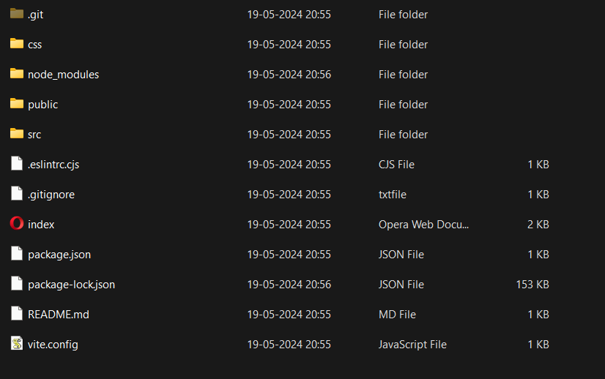

## Components:

## App Component

import { useRef } from "react"

import "./css/style.css"

import Part1 from "./Part1"

import Part2 from "./Part2"

import Part3 from "./Part3"

import Part4 from "./Part4"

import Part5 from "./Part5"

import Part6 from "./Part6"

import Part7 from "./Part7"

import Part8 from "./Part8"

function App() {

  const HeadRef = useRef(null);

  const AboutRef = useRef(null);

  const ProductRef = useRef(null);

  const ContactRef = useRef(null);

  const ClientRef = useRef(null);

  const SubRef = useRef(null);

  const FooterRef = useRef(null);

  return (

    <>

      <div ref = {HeadRef} className="header_section">

        <Part1 refs = {{HeadRef, AboutRef, ProductRef, ContactRef, ClientRef, SubRef, FooterRef}}/>

        <Part2/>

      </div>

      <div ref = {AboutRef} className="about_section layout_padding">

       <Part3/>

      </div>

      <div ref = {ProductRef} className="product_section layout_padding">

       <Part4/>

      </div>

      <div ref = {ContactRef} className="contact_section layout_padding">

       <Part5/>

      </div>

      <div className="client_section layout_padding" ref = {ClientRef}>

       <Part6/>

      </div>

      <div className="subscribe_section layout_padding" ref = {SubRef}>

        <Part7/>

      </div>

      <div className="footer_section layout_padding" ref = {FooterRef}>

        <Part8/>

      </div>

      <div className="copyright_section">

        <div className="container">

          <div className="border"></div>

          <p className="copyright_text">

            2020 All Rights Reserved. Design by{" "}

            <a href="https://html.design">Free html Templates</a>

          </p>

        </div>

      </div>

    </>

  );

}

export default App;

## Navbar Component

import Logo from "./images/logo.png"

import BagIcon from "./images/bag-icon.png"

import Search from "./images/search-icon.png"

import User from "./images/user-icon.png"

const Part1 = ({refs}) => {

    const navItems = [

        {

            name:"Home", ref :refs.HeadRef

        },

        {

            name:"About", ref:refs.AboutRef

        },

        {

            name:"Products", ref:refs.ProductRef

        },

        {

            name:"Blog", ref:refs.SubRef

        },

        {

            name:"Contact Us", ref:refs.ContactRef

        }

    ]

    const handleClick = (item)=>{

        item.ref.current.scrollIntoView({ behavior: 'smooth' });

    }

  return (

<div className="container-fluid">

          <nav className="navbar navbar-expand-lg navbar-light bg-light">

            <div className="logo">

              {/* <a href="index.html"> */}

                <img src={Logo} />

              {/* </a> */}

            </div>

            <button

              className="navbar-toggler"

              type="button"

              data-toggle="collapse"

              data-target="#navbarSupportedContent"

              aria-controls="navbarSupportedContent"

              aria-expanded="false"

              aria-label="Toggle navigation"

            >

              <span className="navbar-toggler-icon"></span>

            </button>

            <div className="collapse navbar-collapse" id="navbarSupportedContent">

              <ul className="navbar-nav mr-auto">

                {

                    navItems.map((item, index)=>{

                        return (

                            <li key={index} onClick={()=>handleClick(item)} className="nav-item cursor-pointer">

                            <a className="nav-link" >

                              {item.name}

                            </a>

                          </li>

                        )

                    })

                }

              </ul>

              <form className="form-inline my-2 my-lg-0">

                <button

                  className="btn btn-outline-success my-2 my-sm-0"

                  type="submit"

                >

                  GET STARTED

                </button>

              </form>

              <div className="search_icon">

                <ul>

                  <li>

                    <a href="#">

                      <img src={User} />

                    </a>

                  </li>

                  <li>

                    <a href="#">

                      <img src={BagIcon} />

                    </a>

                  </li>

                  <li>

                    <a href="#">

                      <img src={Search} />

                    </a>

                  </li>

                </ul>

              </div>

            </div>

          </nav>

        </div>

  )

}

export default Part1

## Hero Component

import LeftArrow from "./images/left-arrow.png"

import Img1 from "./images/img-1.png"

import RightArrow from "./images/right-arrow.png"

const Part2 = () => {

  return (

    <div className="banner_section layout_padding">

    <div className="container">

      <div id="main_slider" className="carousel slide" data-ride="carousel">

        <div className="carousel-inner">

          <div className="carousel-item active">

            <div className="row">

              <div className="col-md-6">

                <h1 className="your_text">Your Favorite</h1>

                <h1 className="Shows_text">Shows And Movies</h1>

                <p className="there_text">

                  There are many variations of passages of Lorem Ipsum

                  available, but the majority have suffered alteration in

                  some form, by injected humour, or

                </p>

                <div className="start_bt">

                  <a href="#">Start Now</a>

                </div>

                <div className="read_bt">

                  <a href="#">Read More</a>

                </div>

              </div>

              <div className="col-md-6">

                <div className="images_1">

                  <img src={Img1} />

                </div>

              </div>

            </div>

          </div>

          <div className="carousel-item">

            <div className="row">

              <div className="col-md-6">

                <h1 className="your_text">Your Favorite</h1>

                <h1 className="Shows_text">Shows And Movies</h1>

                <p className="there_text">

                  There are many variations of passages of Lorem Ipsum

                  available, but the majority have suffered alteration in

                  some form, by injected humour, or

                </p>

                <div className="start_bt">

                  <a href="#">Start Now</a>

                </div>

                <div className="read_bt">

                  <a href="#">Read More</a>

                </div>

              </div>

              <div className="col-md-6">

                <div className="images_1">

                  <img src={Img1} />

                </div>

              </div>

            </div>

          </div>

          <div className="carousel-item">

            <div className="row">

              <div className="col-md-6">

                <h1 className="your_text">Your Favorite</h1>

                <h1 className="Shows_text">Shows And Movies</h1>

                <p className="there_text">

                  There are many variations of passages of Lorem Ipsum

                  available, but the majority have suffered alteration in

                  some form, by injected humour, or

                </p>

                <div className="start_bt">

                  <a href="#">Start Now</a>

                </div>

                <div className="read_bt">

                  <a href="#">Read More</a>

                </div>

              </div>

              <div className="col-md-6">

                <div className="images_1">

                  <img src={Img1} />

                </div>

              </div>

            </div>

          </div>

        </div>

        <a

          className="carousel-control-prev"

          href="#main_slider"

          role="button"

          data-slide="prev"

        >

          <i className="fa-arrow-left">

            <img src={LeftArrow} />

          </i>

        </a>

        <a

          className="carousel-control-next"

          href="#main_slider"

          role="button"

          data-slide="next"

        >

          <i className="fa-angle-right">

            <img src={RightArrow} />

          </i>

        </a>

      </div>

      <div className="banner_section_2">

        <div className="row">

          <div className="col-lg-4 col-sm-12">

            <div className="box_main">

              <div className="internet_icon"></div>

              <h4 className="broadband_text">Broadband</h4>

              <p className="many_text">

                There are many variations of passages of Lorem Ipsum

                available, but the majority have suffered alteration in

                some form, m Ipsum, you need to be

              </p>

            </div>

          </div>

          <div className="col-lg-4 col-sm-12">

            <div className="box_main active">

              <div className="internet_icon1"></div>

              <h4 className="broadband_text active">Broadband</h4>

              <p className="many_text active">

                There are many variations of passages of Lorem Ipsum

                available, but the majority have suffered alteration in

                some form, m Ipsum, you need to be

              </p>

            </div>

          </div>

          <div className="col-lg-4 col-sm-12">

            <div className="box_main">

              <div className="internet_icon2"></div>

              <h4 className="broadband_text">Broadband</h4>

              <p className="many_text">

                There are many variations of passages of Lorem Ipsum

                available, but the majority have suffered alteration in

                some form, m Ipsum, you need to be

              </p>

            </div>

          </div>

        </div>

      </div>

    </div>

  </div>

  )

}

export default Part2

## Services Component

import Img2 from './images/img-2.png'

const Part3 = () => {

  return (

    <div className="container">

    <div className="row">

      <div className="col-md-6">

        <div className="image_2">

          <img src={Img2} />

        </div>

      </div>

      <div className="col-md-6">

        <h1 className="live_text">

          Live Sport and TV-shows for best friends

        </h1>

        <p className="lorem_text">

          It is a long established fact that a reader will be distracted

          by the readable content of a page when looking at its layout.

          The point of using Lorem Ipsum is that it has a more-or-less

          normal distribution of letters,

        </p>

        <div className="online_bt_main">

          <div className="online_bt">

            <a href="#">4K Ultra HD Quality</a>

          </div>

          <div className="online_bt1">

            <a href="#">200+ Online Channels</a>

          </div>

          <div className="read_bt1">

            <a href="#">Read More</a>

          </div>

        </div>

      </div>

    </div>

  </div>

  )

}

export default Part3

## Projects Component

const Part4 = () => {

  return (

    <div className="container">

    <h2 className="tariffs_text">Tariffs</h2>

    <h1 className="choose_text">Choose your plan</h1>

    <p className="lorem_text1">

      Lorem ipsum dolor sit amet, consectetur adipiscing elit. Proin

      bibendum, est ac faucibus hendrerit, mauris ante viverra urna, in

      elementum urna est ut ligula.

    </p>

    <div className="product_section2">

      <div className="row">

        <div className="col-lg-4 col-sm-12">

          <h2 className="easy_text">Easy Surfing</h2>

          <h1 className="internet_text">Internet</h1>

          <div className="month_main clearfix">

            <h1 className="dolor_text">$24.99</h1>

            <h2 className="month_text">Month</h2>

            <p className="long_text">

              It is a long established f act distracteontent{" "}

            </p>

          </div>

          <div className="seemore_main">

            <div className="see_more">

              <a href="#">SEE MORE</a>

            </div>

          </div>

        </div>

        <div className="col-lg-4 col-sm-12">

          <h2 className="easy_text">Impression</h2>

          <h1 className="internet_text">Tv</h1>

          <div className="month_main clearfix">

            <h1 className="dolor_text">$24.99</h1>

            <h2 className="month_text">Month</h2>

            <p className="long_text">

              It is a long established f act distracteontent{" "}

            </p>

          </div>

          <div className="seemore_main">

            <div className="see_more">

              <a href="#">SEE MORE</a>

            </div>

          </div>

        </div>

        <div className="col-lg-4 col-sm-12">

          <h2 className="easy_text">Premium Plan</h2>

          <h1 className="internet_text">Internet + TV + Phone</h1>

          <div className="month_main clearfix">

            <h1 className="dolor_text">$24.99</h1>

            <h2 className="month_text">Month</h2>

            <p className="long_text">

              It is a long established f act distracteontent{" "}

            </p>

          </div>

          <div className="seemore_main">

            <div className="see_more">

              <a href="#">SEE MORE</a>

            </div>

          </div>

        </div>

      </div>

    </div>

  </div>

  )

}

export default Part4

## Contact Component

const Part5 = () => {

  return (

    <div className="container">

      <h1 className="check_text">

        Check ability to connect our services in your area

      </h1>

      <div className="contact_section2">

        <div className="addres_main">

          <div className="input_bg">

            <h3 className="fact_text">

              It is a long established fact that a reader will be distracted

            </h3>

            <input

              type="text"

              className="address_text"

              placeholder="Enter your address"

              name="text"

            />

            <button type="button" className="get_bt">

              GET STARTED

            </button>

          </div>

        </div>

      </div>

    </div>

  );

};

export default Part5;

## What our clients say

import Img3 from './images/img-3.png'

import Quote from "./images/quote-icon.png"

const Part6 = () => {

  return (

    <div className="container">

      <h1 className="client_taital">What our clients say</h1>

      <div className="client_section2 layout_padding">

        <div className="row">

          <div className="col-sm-4">

            <div className="client_image">

              <img src={Img3} />

            </div>

          </div>

          <div className="col-sm-8">

            <div className="miller_text">

              Miller

              <span className="quote_icon">

                <img src={Quote} />

              </span>

            </div>

            <p className="ipsum_text">

              ipsum dolor sit amet, consectetur adipiscing elit, sed do eiusmod

              tempor incididunt ut labore et dolore magna aliqua. Ut enim ad

              minim veniam, quis nostrud exercitation ullamco laboris nisi ut

              aliquip ex ea commodo consequat. Duis aute irure dolor in

              reprehenderit in voluptate velit esse cillum dolore eu fugiat

              nulla pariatur. Excepteur sint occaecat cupidatat non proident,

              sunt in culpa qui officia deserunt mollit anim id e

            </p>

          </div>

        </div>

      </div>

    </div>

  );

};

export default Part6;

## Subscribe

const Part7 = () => {

  return (

    <div className="container">

      <div className="row">

        <div className="col-sm-4">

          <h1 className="subscribe_text">Subscribe Now</h1>

        </div>

        <div className="col-sm-8">

          <div className="mail_main">

            <input

              type="text"

              className="address_text1"

              placeholder="Enter your address"

              name="text"

            />

            <button type="button" className="get_bt1">

              GET STARTED

            </button>

          </div>

        </div>

      </div>

    </div>

  );

};

export default Part7;

## Footer

import Fb from "./images/fb-icon.png"

import Footer from "./images/footer-logo.png"

import InstaIcon from "./images/instagram-icon.png"

import Linkedin from "./images/linkedin-icon.png"

import Twitter from "./images/twitter-icon.png"

const Part8 = () => {

  return (

    <div className="container">

    <div className="row">

      <div className="col-lg-3 col-sm-6">

        <div className="fooer_logo">

          <img src={Footer} />

        </div>

        <h1 className="customer_text">CUSTOMER SERVICE</h1>

        <p className="footer_lorem_text">

          There are many variat ions of passages of L orem Ipsum available

          , but the majority h ave suffered altera tion in some form, by{" "}

        </p>

      </div>

      <div className="col-lg-3 col-sm-6">

        <h1 className="customer_text">LET US HELP YOU</h1>

        <p className="footer_lorem_text">

          There are many variat ions of passages of L orem Ipsum available

          , but the majority h ave suffered altera tion in some form, by{" "}

        </p>

      </div>

      <div className="col-lg-3 col-sm-6">

        <h1 className="customer_text">INFORMATION</h1>

        <p className="footer_lorem_text1">

          About Us

          <br />

          Careers

          <br />

          Sell on shopee

          <br />

          Press & News

          <br />

          Competitions

          <br />

          Terms & Conditions

        </p>

      </div>

      <div className="col-lg-3 col-sm-6">

        <h1 className="customer_text">OUR SHOP</h1>

        <p className="footer_lorem_text">

          There are many variat ions of passages of L orem Ipsum available

          , but the majority h ave suffered altera tion in some form, by{" "}

        </p>

        <div className="social_icon">

          <ul>

            <li>

              <a href="#">

                <img src={Fb} />

              </a>

            </li>

            <li>

              <a href="#">

                <img src={Twitter} />

              </a>

            </li>

            <li>

              <a href="#">

                <img src={InstaIcon} />

              </a>

            </li>

            <li>

              <a href="#">

                <img src={Linkedin} />

              </a>

            </li>

          </ul>

        </div>

      </div>

    </div>

  </div>

  )

}

export default Part8

# Results

“Dicet TV” Successfully serves it purpose of easing the access of Shows and movies.

**GitHub Link: https://github.com/Sanchit0401**

## Project Screenshots for all scenarios:

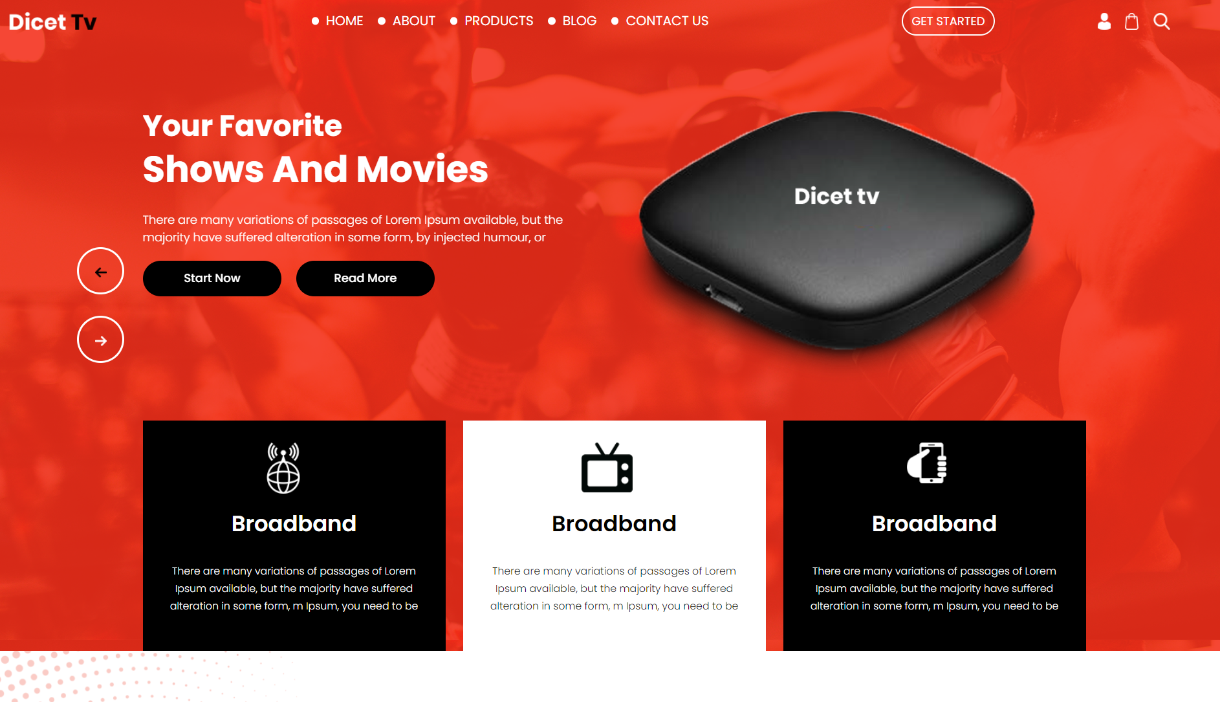

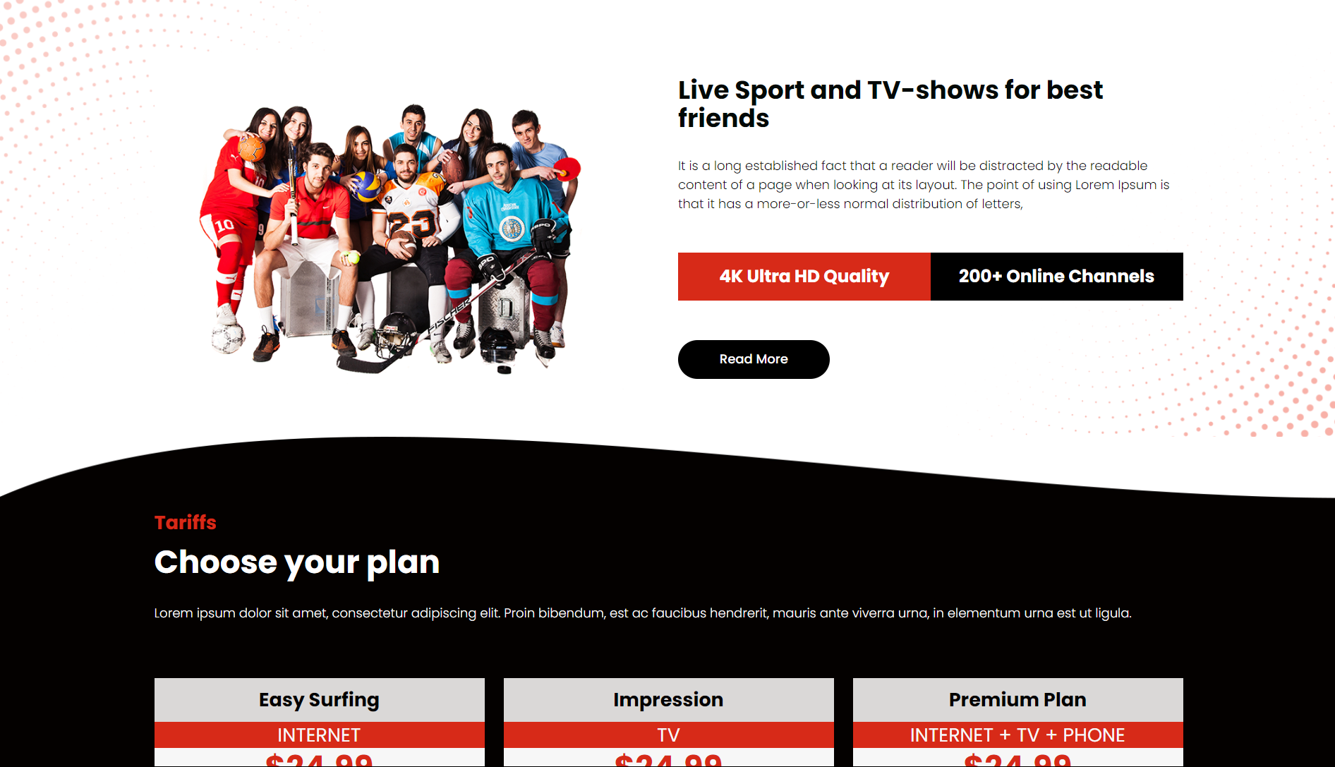

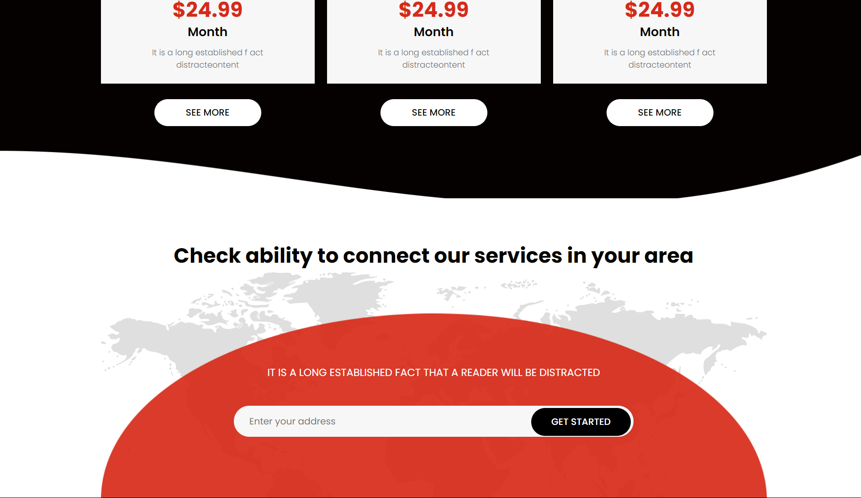

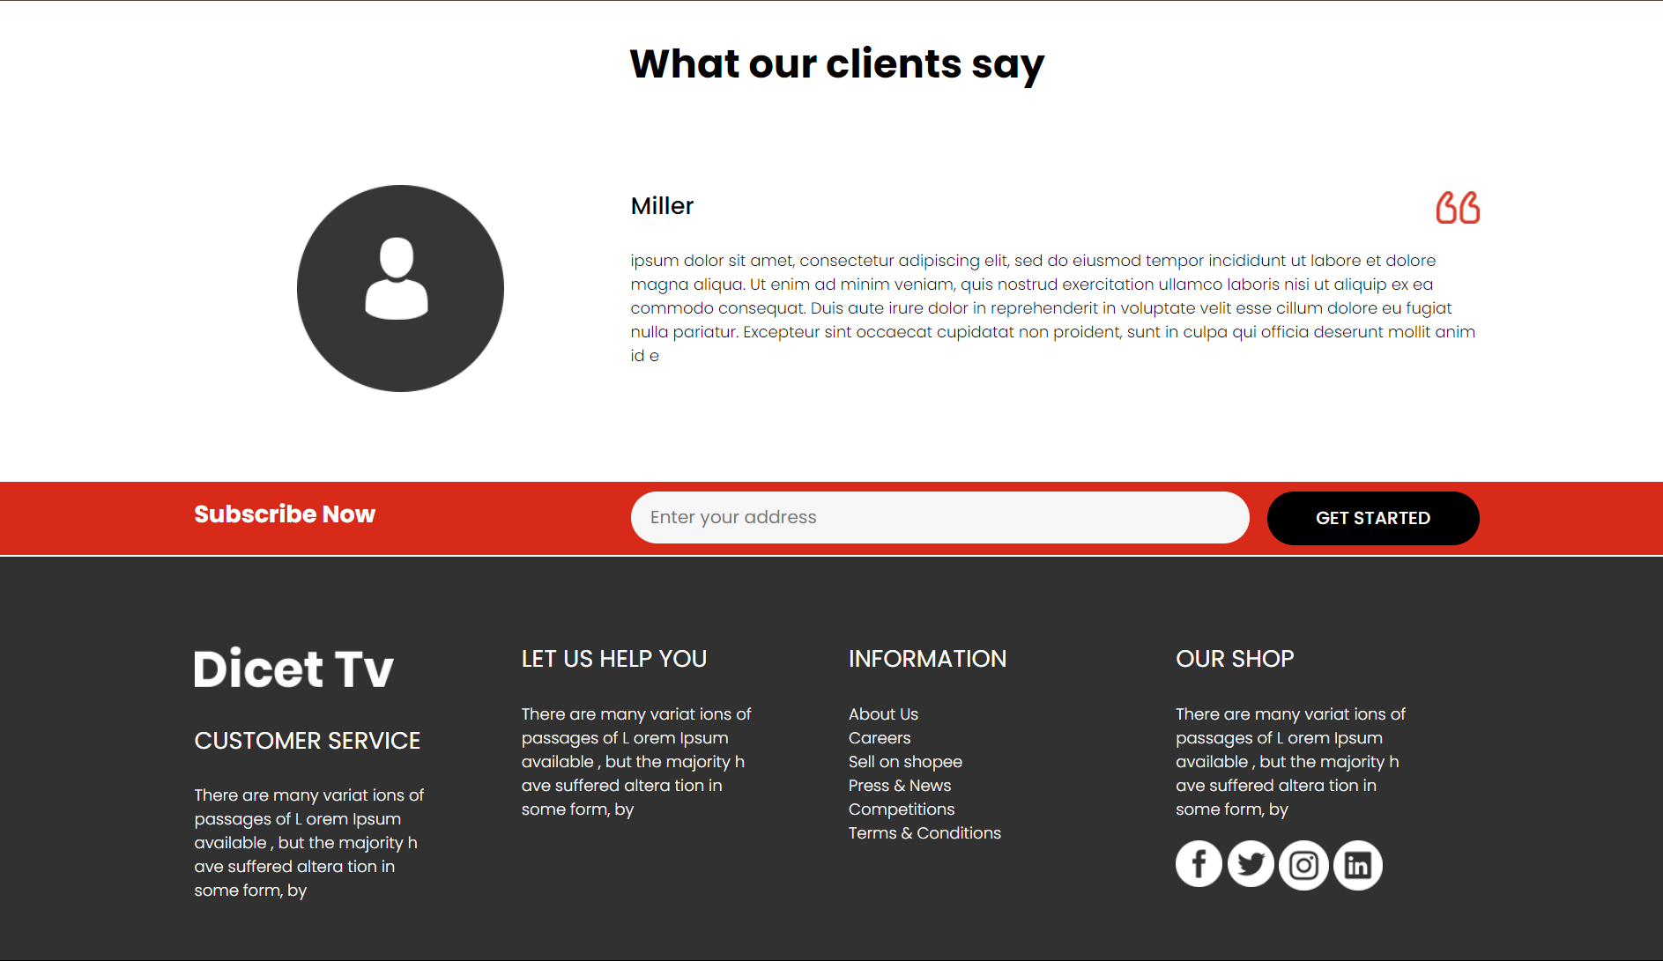

* **Accuracy:** The “Dicet TV” web App, implemented in ReactJS is an accurate representation of the power of ReactJS and CSS.
* **User Experience:** The user interface design, leveraging CSS, provides a seamless and visually appealing experience across different devices and screen sizes. Interactive elements and real-time feedback enhance usability and engagement.
* **Documentation and Deployment:** Comprehensive documentation guides users through setup, usage, and troubleshooting. Deployment on a web server with domain access ensures public availability, while regular updates maintain relevance and accuracy.
* **Availability for the Community:** This project is available on Github on my Profile in a public repository so that people can check it out and can learn.

# References :

# <http://react.dev/>

# <https://www.youtube.com/>